Embedded DisplayPort Test Adapter
User Manual



Table of Contents
Introduction 3
Product Inspection 6
The Embedded DisplayPort Test Adapter Care and Handling Precautions 7
General Test Adapter, Cable, and Connector 9
Handling and storage 9
Visual inspection 9
Cleaning 9
Making Connections 9
Electrostatic Discharge Information 10
User Model 11
Calibration 14
SOLT 15
1X-THRU 16
Calibration Through De-Embedding 17
Mechanical and Environmental Specifications 18
Statement and Explanation for Pin-1 Physical Location 22
Electrical Specifications 23
Compliance with Environmental Legislation 34
WEEE Compliance Statement 34
Compliance To RoHS 2 Substance Restrictions 34
Glossary of Terms 35
Index 36

Introduction
This user’s guide documents the Embedded DisplayPort Test Adapter (EDP-TPA) and Calibration Module. The test adapter, shown in Figure 1 and Figure 2, tests Embedded DisplayPort Interface (eDP) cables, devices, or displays against the VESA DisplayPort™ PHY Compliance Test Specification. The test adapters are passive components and do not perform pre-emphasis or equalization. The Calibration Module, shown on Page 14, is used to zero-out test adapter attributes (using SOLT, with either the 1X-THRU or the 2X-THRU). This moves the reference plane for TP3 to the pins of the main connector on the TPA.
The TPA test adapter assembly allows easy access, via SMA connections, to measure or inject up to four Main Link Lanes and one Auxiliary Lane. These test adapters also provide access to all other low-speed signals via a 20-position low-speed connector and a 6-position low-speed connector. (See Table 3 and Table 4 for pin and signal definitions.) The general configuration can support four power/ground planes independent of the high-speed ground. In addition, it can support up to eleven low-speed pins for control/support of the high-speed lanes. The
6-position low-speed connector brings out connections to the Aux Control Adapter (Optional product, see Auxiliary Control Test Adapter User Manual for additional product information and usage details).
The EDP TPA supports all VESA Embedded DisplayPort™ Standard configurations. (20 pin eDP with CCFL Backlight, 30 pin eDP with LED Backlight without LED Driver, 30pin eDP with LED Backlight with LED driver, and 40pin eDP with LED Backlight with LED driver. It also supports a 50 pin eDP utilizing IPEX FPL-II connectors (supports AMD specific eDP configurations).

NOTE: To avoid damaging the cables, use the handling techniques described in the Care and Handling section before making any connections or configuring a test setup.
Always use a static-safe workstation when performing tests, as explained in the “Electrostatic Discharge Information” section.

20-Position Low-Speed Connector
Housing
40-Position Embedded DisplayPort Receptacle Connector Shown
Micro-Coax Cable Swing-Latch Retainer
6-Position Low-Speed Connector
10 SMA’s for High-Speed Testing (6 SMA’s for 2-Lane Plus AUX). NOTE: Female SMA’s with 6-Inch Coaxial cables shown for Cabline VS equipped TPA’s. Male SMA’s with 12-Inch cables used on FPL-II 50 position equipped TPA.
ATTENTION
Pin-1 This Side for all Versions (See Statement on Page 22 of this Document)

Figure 1. The eDP Test Adapter (Receptacle)

Flip-Lock to be pivoted
away from TPA Circuit Assembly during test
(I-PEX Cabline VS Connectors only)
Micro-Coax Display Patch Cable Assembly, 4-Inches Long Overall
Swing-Latch Release Button for Micro-Coax
Display Patch Cable Assembly
ATTENTION
Pin-1 This Side for all Versions (See Statement on Page 22 of this Document)
Figure 2. The eDP Test Adapter (Receptacle) shown with the Micro-Coax Display Patch Cable

NOTE: The metal shell of the receptacle (EDP-TPA) connector is configured to tie high-speed ground to chassis ground of the connector. This is because the shell is used to connect to the coax shields of the mating plug.
The low-speed 20-position receptacle connector is keyed and latching (Molex part number 43025-2000). The mating plug connector housing and contact pins for 26-30awg wire are provided with each eDP-TPA assembly (Molex part numbers 43020-2001 for the 20-position housing and 43031-0011 for the 26-30awg pin contacts). Replacement plug parts can be purchased through Molex distributors.
The low-speed 6-position receptacle connector is keyed and latching (Molex part number 43645-0600). The mating plug connector housing and contact pins for 26-30awg wire are provided with each eDP-TPA assembly (Molex part numbers 43640-0601 for the 6-position housing and 43031-0011 for the 26-30awg pin contact). Replacement plug parts can be purchased through Molex distributors.

Product Inspection
Upon receiving the EDP-TPA from Wilder Technologies, perform the following product inspection:
Inspect the outer shipping container, foam-lined instrument case, and product for damage. Retain the outer cardboard shipping container until the contents of the shipment have been inspected for completeness and the product has been checked mechanically and electrically. Use the foam-lined instrument case for secure storage of the Wilder Technologies Embedded DisplayPort Test Adapter when not in use.

Locate the shipping list and verify that all items ordered were received.

In the unlikely event that the product is defective or incomplete, the “Limited Warranty” section discusses how to contact Wilder Technologies for technical assistance and/or how to package the product for return.

The Embedded DisplayPort Test Adapter Care and Handling Precautions
The Embedded DisplayPort Test Adapter requires careful handling to avoid damage. Improper handling techniques, or using too small a cable bend radius, can damage the coaxial cable connections within the adapter housing or the cables themselves. This can occur at any point along the cable. To achieve optimum performance and to prolong the EDP-TPA’s life, observe the following handling precautions:
Caution 1: Avoid Torque Forces (Twisting)
While individual high-speed coaxial cables within the test adapter have some rotational freedom, twisting the EDP-TPA as a unit, with one end held stationary, in excess of +/- 90° may damage or severely degrade performance. Adherence to Caution 5 (below) helps to avoid exceeding twist limits.

Caution 2: Avoid Sharp Cable Bends
Never bend high-speed coaxial cables or micro-coax cables into a radius of 26 mm (1-inch) or less. Never bend cables greater than 90°. Single or multiple cable bends must be kept within this limit. Bending the EDP-TPA cables less than a 26mm (1-Inch) radius will permanently damage or severely degrade test adapter performance.

Caution 3: Avoid Cable Tension (Pull Forces)
Never apply tension (pull forces) to an individual high-speed coaxial cable that is greater than 2.3 kg (5 lbs.), and never apply tension to a mated micro-coax cable that is greater than 0.45 kg (1 lb). To avoid applying tension, always place accessories and equipment on a surface that allows adjustment to eliminate tension on the EDP-TPA and cables. Use adjustable elevation stands or apparatus to accurately place and support the EDP-TPA.

Caution 4: Connect the EDP-TPA First
To prevent twisting, bending, or applying tension to the coaxial cables when connecting a EDP-TPA, always attach the EDP-TPA to the device under test (DUT) or cable under test before attaching any SMA connectors. Carefully align the Embedded DisplayPort connectors and then gently push the connectors together until fully seated.
NOTE: To help improve the useful life of the EDP receptacle connector, the “Flip-Lock” feature found on I-PEX Cabline VS series micro-coax cables has been disabled on the test adapter and cannot be engaged. Instead, a cable retention/strain-relief swing-latch is provided and must be used to maintain the connection between the micro-coax cable assembly and the EDP test adapter. To prevent test performance anomalies while testing, the micro-coax cable Flip-Lock feature should be pivoted 90 degrees (perpendicular) from TPA circuit assembly. To release the swing-latch, slide the latch-release away from the mated cable assembly and pivot the swing-latch open.
If the EDP-TPA must be turned or twisted to make connection to the DUT, avoid using the EDP-TPA housing alone to make this occur. Try to distribute the torque forces along the length of the test setup and cabling. If this is not possible, it is recommended to first loosen or disconnect the SMA connections at the EDP-TPA, make the connection to the DUT and then re-tighten or attach the test equipment leads.

Caution 5: Carefully Make SMA Connections
To connect the EDP-TPA SMA connectors, follow these steps:
- Hold the cable stationary by grasping the cable at the black heat-shrink section near the SMA connector.
- Insert the mating SMA barrel and hand-tighten the free-spinning SMA nut onto the connector while avoiding pulling, bending, or twisting the EDP-TPA coaxial cable.
- The EDP-TPA female SMA connectors have flats that accept an open-end 1/4-inch or 6.5mm wrench. (Male SMA connectors have flats that accept an open-end 5/16-inch or 8mm wrench.) When attaching instrument cables to the EDP-TPA, it is recommended that the EDP-TPA connectors be mechanically held and the instrument cable SMA connectors be tightened to the equipment manufacturer’s torque recommendations, normally 5 in-lbs., using an open-end torque wrench. The opposite is true when the EDP-TPA utilizes male SMA connectors.
If the test set-up requires repositioning, first loosen or disconnect the SMA connections to avoid twisting, bending, or tension.
NOTE: A drop in signal amplitude by half or 6db during the testing of a lane may indicate that a cable has been mechanically pulled free of coaxial cable connections internal to the assembly. This could be determined by checking if the cable has any lateral play relative to the TPA. This would only occur when the TPA has exceeded the pull force as specified within the mechanical specification. If the cable cannot be re-seated, the test adapter will need to be sent back to the factory for service.
Caution 6: Independently Support Instrument Cables or Accessories
Excessive weight from instrument cables and/or accessories connected to the EDP-TPA can cause damage or affect the test adapter performance. Be sure to provide appropriate means to support and stabilize all test set-up components.

General Test Adapter, Cable, and Connector
Observing simple precautions can ensure accurate and reliable measurements.

Handling and storage
Before each use of the EDP-TPA, ensure that all connectors are clean. Handle all cables carefully and store the EDP-TPA in the foam-lined instrument case when not in use, if possible. Do not set connectors contact end down. Install the SMA protective end caps when the EDP-TPA is not in use.

Visual inspection
Be sure to inspect all cables carefully before making a connection. Inspect all cables for metal particles, scratches, deformed threads, dents, or bent, broken, or misaligned center conductors. Do not use damaged cables.

Cleaning
If necessary, clean the connectors using low-pressure (less than 60 PSI) compressed air or nitrogen with an effective oil-vapor filter and condensation trap. Clean the cable threads, if necessary, using a lint-free swab or cleaning cloth moistened with isopropyl alcohol. Always completely dry a connector before use. Do not use abrasives to clean the connectors. Re-inspect connectors, making sure no particles or residue remains.

Making Connections
Before making any connections, review the “Care and Handling Precautions” section. Follow these guidelines when making connections:
Align cables carefully
Make preliminary connection lightly
To tighten, turn connector nut only
Do not apply bending force to cable
Do not over- tighten preliminary connections
Do not twist or screw-in cables
Use an appropriately sized torque wrench (depends on SMA gender), and do not tighten past the “break” point of the torque wrench (normally set to 5 in-lbs.)

Electrostatic Discharge Information
Protection against electrostatic discharge (ESD) is essential while connecting, inspecting, or cleaning the EDP-TPA test adapter and connectors attached to a static-sensitive circuit (such as those found in test sets).
Electrostatic discharge can damage or destroy electronic components. Be sure to perform all work on electronic assemblies at a static-safe workstation, using two types of ESD protection:
Conductive table-mat and wrist-strap combination
Conductive floor-mat and heel-strap combination
When used together, both of these types provide a significant level of ESD protection. Used alone, the table-mat and wrist-strap combination provide adequate ESD protection. To ensure user safety, the static-safe accessories must provide at least 1 MΩ of isolation from ground. Acceptable ESD accessories may be purchased from a local supplier.
WARNING: These techniques for a static-safe workstation should not be used when working on circuitry with a voltage potential greater than 500 volts.

User Model
The Embedded DisplayPort TPA supports all testing of the VESA DisplayPort CTS PHY 1.2 and VESA Embedded DisplayPort Standard 1.5a. It is capable of performing well beyond the scope of measurements contained in the CTS PHY, limited only by the specifications, environmental, care and handling as stated in this document.
The following examples are suggestions for possible testing setups.
In this first example, an Embedded DisplayPort TPA and micro-coax patch cable act as a sink:
In the second example, the Embedded DisplayPort TPA and micro-coax patch cable act as a source:
The third example shows two Embedded DisplayPort receptacle TPAs acting as source and sink:

Calibration
The Embedded DisplayPort Receptacle Test Adapter is a passive component. Therefore, calibration for the errors generated must occur within the test instrumentation that drives the sink or looks at the response of the source.
Figure 3. Calibration module (EDP-TPA-C) showing standard 6-inch cable on SOLT and 3-inch cables connected to the 1X-THRU.

SOLT

SHORT, OPEN, LOAD, and 2X-THRU. (SOLT) are calibration standards used to compensate for errors associated with the TPA when used for Jitter measurement, TDR, TDT, and VNA testing. SOLT represents the same electrical length and losses as the TPA through the Embedded DisplayPort connector pad, and enables the test engineer to compensate for the following six repeatable, systematic errors that occur when moving the reference plane:
Signal leakage effects: Directivity errors
Signal leakage effects: Crosstalk errors
Reflection effects: Source Impedance Mismatching errors
Reflection effects: Load Impedance Mismatching errors
Bandwidth effects: Receiver Transmission in Test Equipment errors
Bandwidth effects: Receiver Reflection-tracking in Test Equipment errors
These errors need to be corrected on each port. Refer to the Instrument Manual for instructions on the instrument’s specific calibration process.
NOTE: The reference plane is the boundary, both physically and electrically, between the calibrated and uncalibrated portions of the circuit. Everything outside the reference plane is considered part of the DUT. Any instrument that does not use calibration defines the DUT as the total of externally connected components. If the TPA-C is not used, all of the Embedded DisplayPort TPA and the 6-inch cables, as well as cables connecting the 6-inch cables to the test instrument, would be a part of the DUT.
Non-repeatable errors, such as drift or random errors can be reduced but not corrected. Drift errors aggregate over time or with environmental changes such as temperature shift. To eliminate drift errors, perform another calibration.
A random error cannot be corrected through calibration since the error occurred randomly. Random errors are typically associated with either test instrument noise or test repeatability problems. Reduce test instrument noise by increasing source power, lowering the IF bandwidth, or averaging results over multiple sweeps. Reduce test repeatability problems through the use of a torque wrench or, again, by averaging over multiple sweeps.

1X-THRU
The 1X-THRU is a calibration feature used to calibrate time domain instrumentation (for example, pre-emphasized pulse generators or AWGs, arbitrary waveform generators). 1X-THRU calibration compensates two error sources – cable losses and group delay:
Cable Losses – Cable losses associated with the Embedded DisplayPort TPA, and its respective cabling that’s connected to the test source, consist of skin loss and, to a lesser extent, dielectric loss. Pre-emphasis or de-emphasis is used at the signal source to correct for these cable losses. Pre-emphasis is a boost of the signal level just after an edge transition; de-emphasis is a reduction in the low-speed amplitude of the signal source. Typically, on a de-emphasized signal the levels have to be reset to attain the same output levels. Resultant signals from either pre-emphasis or de-emphasis are identical relative to the DUT.

For the purposes of this discussion, pre-emphasis will be used. To set the pre-emphasis, first determine the amount of signal boost by connecting the signal source, via the 1X-THRU and the respective cable used to connect the DUT to the source to a high-speed oscilloscope or a jitter measurement device. Trigger the oscilloscope or jitter measurement device using a trigger from the source. The trigger, a single event, indicates the start of the signal being sent to the DUT. Adjust pre-emphasis to maximize the eye opening.

Group Delay – Group delay is the second error source for 1X-THRU calibration. When the DUT generates an output signal, it can be used to measure delay. To create a baseline delay measurement, connect the output signal cable to the input signal cable and the 1X-THRU. To determine corrected DUT delay, subtract this baseline measurement from the DUT delay measurements.

Calibration Through De-Embedding
The Embedded DisplayPort Test Adapters (EDP-TPA) are fully passive components. Therefore, calibration compensating for the losses must occur within the test instrumentation that drives the Embedded DisplayPort sink device or looks at the response of the Embedded DisplayPort source device.
The EDP-TPA’s have Touchstone S4P files for de-embedding the electrical length and
losses within the TPA up to the EDP-TPA connector interface pads. (Contact Wilder Technologies, support@wilder-tech.com, to obtain a copy of the S4P files.) The Touchstone S4P files enable the test engineer to compensate for the following six repeatable, systematic errors that occur when moving the reference plane:
Signal leakage effects: Directivity errors
Signal leakage effects: Crosstalk errors
Reflection effects: Source Impedance Mismatching errors
Reflection effects: Load Impedance Mismatching errors
Bandwidth effects: Receiver Transmission in Test Equipment errors
Bandwidth effects: Receiver Reflection-tracking in Test Equipment errors
These errors are corrected on each port. Refer to the Instrument Manual for instructions on the instrument’s specific de-embedding process.
NOTE: The reference plane is the boundary, both physically and electrically, between the calibrated and uncalibrated portions of
the circuit. Everything outside the reference plane is considered
part of the DUT. Any instrument that does not use calibration or de-embedding of the test fixture defines the DUT as the total of externally connected components. If the de-embedding file is not used, all of the EDP-TPA and associated coaxial cables, as well as cables connecting the TPA assembly to the test instrument, would be a part of the DUT.
Non-repeatable errors, such as drift or random errors, can be reduced but not corrected. Drift errors aggregate over time or with environmental changes such as temperature shift. To eliminate drift errors, perform an instrumentation-level calibration.
A random error cannot be corrected through calibration since the error occurred randomly. Random errors are typically associated with either test instrument noise or test repeatability problems. Reduce test instrument noise by increasing source power, lowering the IF bandwidth, or averaging results over multiple sweeps. Reduce test repeatability problems through the use of a torque wrench or, again, by averaging over multiple sweeps.

Mechanical and Environmental Specifications
NOTE: All specifications in this manual are subject to change.

Table 1. General Specifications
Item | Description
Usage Environment | Controlled indoor environment
Test Adapter Length (w/standard cables) | 193.3 mm +/- 2 mm (7.61 inches +/- .08 inches) (Characteristic)
Test Adapter Length (w/12-inch cables) | 345.7 mm +/- 2 mm (13.61 inches +/- .08 inches) (Characteristic)
Operating Temperature | 0°C to +55°C (32°F to +131°F) (Characteristic)
Storage Temperature | -40°C to +70°C (-40°F to +158°F) (Characteristic)

EDP-TPA Cable Pinout
The EDP-TPA cables provide six or ten SMA connectors (Main Link and Auxiliary signals) and two low-speed connectors. Labels clearly mark each cable or connector. The following figure refers to pin-description tables for each of the two connector types.
Receptacle Pin Assignments (See Table 5)
Color ID for Differential Pair (See Table 2)
SMA
Connectors (See Table 2)
Color ID for
Data Line Polarity
(See Table 2)

Low-Speed Connector (See Table 3)
Low-Speed Connector (See Table 4)
ATTENTION
Pin-1 This Side for all Versions (See Statement on Page 22 of this Document)

Figure 4. Cable Connectors

Table 2. SMA Cable Connectors (High-Speed)
Label for 40 and 50 pin eDP | Label for 20 and 30 pin eDP | Color ID for Differential Pair | Color ID for Polarity | Description
Lane3_N | - | Red | Black | Differential Data Lane 3- for Source or Sink
Lane3_P | - | Red | Red | Differential Data Lane 3+ for Source or Sink
Lane2_N | - | Blue | Black | Differential Data Lane 2- for Source or Sink
Lane2_P | - | Blue | Red | Differential Data Lane 2+ for Source or Sink
Lane1_N | Lane1_N | Green | Black | Differential Data Lane 1- for Source or Sink
Lane1_P | Lane1_P | Green | Red | Differential Data Lane 1+ for Source or Sink
Lane0_N | Lane0_N | Yellow | Black | Differential Data Lane 0- for Source or Sink
Lane0_P | Lane0_P | Yellow | Red | Differential Data Lane 0+ for Source or Sink
AUX_P | AUX_P | White | Red | Differential Auxiliary Channel Positive (+)
AUX_N | AUX_N | White | Black | Differential Auxiliary Channel Negative (-)

Table 3. EDP-TPA 6-position Cable Connector “P6” (Low-Speed)
Label | Pin No. | Color ID for TPA | Description
HPD | Pin 1 | Brown | Hot Plug Detect
PWR | Pin 2 | Red | DP_PWR
RTN | Pin 3 | Orange | DP_RTN
GND | Pin 4 | Yellow | Ground
NC | Pin 5 | Green | No Connect
NC | Pin 6 | Blue | No Connect

Table 4. EDP-TPA 20-Position Cable Connector “P5” (Low-Speed)
Pin | Label for  20-pin eDP | Label for  30-pin eDP | Label for  30-pin eDP L | Label for  40-pin eDP L | Label for  50-pin eDP | Color ID for  TPA (Receptacle) | Description
1 | LCDG | LCDG | LCDG | LCDG | GND | Brown | LCD logic and driver ground
2 | LCDV | LCDV | LCDV | LCDV | VDDE | Red | LCD logic and driver power
3 | NC-1 | NC-1 | NC-1 | NC-1 | NC50 | Orange | LCD Manufacturers use
4 | NC20 | VDC6 | NC25 | NC35 | LED5 | Yellow | LCD Manufacturers use/ LED Cathode
5 | NC19 | NC19 | BLDM | BLDM | BLDM | Green | LCD Manufacturers use/ Backlight Dim
6 | NC18 | NC18 | BLEN | BLEN | BLEN | Blue | LCD Manufacturers use/ Backlight Enable
7 | HPD | HPD | HPD | HPD | HPD | Violet | Hot Plug Detect
8 | SELF | SELF | SELF | SELF | TP | Gray | LCD panel self enable test/ Test Point
9 | - | VDC | BL-V | BL-V | VDBL | White | LED Anode/ Backlight power
10 | - | - | BL-G | BL-G | VDSP | Black | Backlight ground/ third supply
11 | LCDG | LCDG | LCDG | LCDG | GND | Brown | LCD logic and driver ground
12 | LCDV | LCDV | LCDV | LCDV | VDDE | Red | LCD logic and driver power
13 | - | VDC1 | NC30 | NC40 | LED0 | Orange | LCD Manufacturers use/ LED Cathode
14 | - | VDC2 | NC24 | NC34 | LED1 | Yellow | LCD Manufacturers use/ LED Cathode
15 | - | VDC3 | - | - | LED2 | Green | Not used/ LED Cathode
16 | - | VDC4 | - | - | LED3 | Blue | Not used/ LED Cathode
17 | - | VDC5 | - | - | LED4 | Violet | Not used/ LED Cathode
18 | GND | GND | GND | GND | GND | Gray | RF Ground
19 | - | VDC | BL-V | BL-V | VDBL | White | LED Anode/ Backlight power
20 | - | - | BL-G | BL-G | VDSP | Black | Backlight ground/ third supply

Table 5. Embedded DisplayPort Receptacle “P1” Pin Assignments (See Statement on the following page for
Pin-1 physical location information and explanation.)
Pin | 20-pin eDP | 30-pin eDP | 30-pin eDP L | Pin | 40-pin eDP L | Pin | 50-pin eDP
 |  |  |  | 1 | NC-1 (P2-3) | 50 | NC-50 (P2-3)
 |  |  |  | 2 | GND (P2-18) | 49 | GND (P2-18)
 |  |  |  | 3 | LANE3_N | 48 | LANE3_N
 |  |  |  | 4 | LANE3_P | 47 | LANE3_P
 |  |  |  | 5 | GND (P2-18) | 46 | GND (P2-18)
 |  |  |  | 6 | LANE2_N | 45 | LANE2_N
1 | NC-1 (P2-3) | NC-1 (P2-3) | NC-1 (P2-3) | 7 | LANE2_P | 44 | LANE2_P
2 | GND (P2-18) | GND (P2-18) | GND (P2-18) | 8 | GND (P2-18) | 43 | GND (P2-18)
3 | LANE1_N | LANE1_N | LANE1_N | 9 | LANE1_N | 42 | LANE1_N
4 | LANE1_P | LANE1_P | LANE1_P | 10 | LANE1_P | 41 | LANE1_P
5 | GND (P2-18) | GND (P2-18) | GND (P2-18) | 11 | GND (P2-18) | 40 | GND (P2-18)
6 | LANE0_N | LANE0_N | LANE0_N | 12 | LANE0_N | 39 | LANE0_N
7 | LANE0_P | LANE0_P | LANE0_P | 13 | LANE0_P | 38 | LANE0_P
8 | GND (P2-18) | GND (P2-18) | GND (P2-18) | 14 | GND (P2-18) | 37 | GND (P2-18)
9 | AUX_P | AUX_P | AUX_P | 15 | AUX_P | 36 | AUX_P
10 | AUX_N | AUX_N | AUX_N | 16 | AUX_N | 35 | AUX_N
11 | GND (P2-18) | GND (P2-18) | GND (P2-18) | 17 | GND (P2-18) | 34 | GND (P2-18)
12 | LCDV (P2-2, 12) | LCDV (P2-2, 12) | LCDV (P2-2, 12) | 18 | LCDV (P2-2, 12) | 33 | VDDE (P2-2, 12)
13 | LCDV (P2-2, 12) | LCDV (P2-2, 12) | LCDV (P2-2, 12) | 19 | LCDV (P2-2, 12) | 32 | VDDE (P2-2, 12)
14 | SELF (P2-8 ) | SELF (P2-8 ) | SELF (P2-8 ) | 20 | LCDV (P2-2, 12) | 31 | TP (P2-8 )
15 | LCDG (P2-1, 11) | LCDG (P2-1, 11) | LCDG (P2-1, 11) | 21 | LCDV (P2-2, 12) | 30 | GND (P2-1, 11)
16 | LCDG (P2-1, 11) | LCDG (P2-1, 11) | LCDG (P2-1, 11) | 22 | SELF (P2-8 ) | 29 | GND (P2-1, 11)
17 | HPD (P2-7) | HPD (P2-7) | HPD (P2-7) | 23 | LCDG (P2-1, 11) | 28 | HPD (P2-7)
18 | NC18 (P2-6) | NC18 (P2-6) | BL-G (P2-10, 20) | 24 | LCDG (P2-1, 11) | 27 | NC
19 | NC19 (P2-5) | NC19 (P2-5) | BL-G (P2-10, 20) | 25 | LCDG (P2-1, 11) | 26 | GND (P2-1, 11)
20 | NC20 (P2-4) | VDC1 (P2-13) | BL-G (P2-10, 20) | 26 | LCDG (P2-1, 11) | 25 | GND (P2-1, 11)
21 |  | VDC2 (P2-14) | BL-G (P2-10, 20) | 27 | HPD (P2-7) | 24 | GND (P2-1, 11)
22 |  | VDC3 (P2-15) | BLEN (P2-6) | 28 | BL-G (P2-10, 20) | 23 | GND (P2-1, 11)
23 |  | VDC4 (P2-16) | BLDM (P2-5) | 29 | BL-G (P2-10, 20) | 22 | BLEN (P2-6)
24 |  | VDC5 (P2-17) | NC24 (P2-14) | 30 | BL-G (P2-10, 20) | 21 | BLDM (P2-5)
25 |  | VDC6 (P2-4) | NC25 (P2-4) | 31 | BL-G (P2-10, 20) | 20 | NC
26 |  | NC | BL-V (P2-9, 19) | 32 | BLEN (P2-6) | 19 | NC
27 |  | VDC (P2-9, 19) | BL-V (P2-9, 19) | 33 | BLDM (P2-5) | 18 | VDSP (P2-10, 20)
28 |  | VDC (P2-9, 19) | BL-V (P2-9, 19) | 34 | NC34 (P2-14) | 17 | VDSP (P2-10, 20)
29 |  | VDC (P2-9, 19) | BL-V (P2-9, 19) | 35 | NC35 (P2-4) | 16 | VDSP (P2-10, 20)
30 |  | NC | NC30 (P2-13) | 36 | BL-V (P2-9, 19) | 15 | VDSP (P2-10, 20)
 |  |  |  | 37 | BL-V (P2-9, 19) | 14 | LED0 (P2-13)
 |  |  |  | 38 | BL-V (P2-9, 19) | 13 | LED1 (P2-14)
 |  |  |  | 39 | BL-V (P2-9, 19) | 12 | LED2 (P2-15)
 |  |  |  | 40 | NC40 (P2-13) | 11 | LED3 (P2-16)
 |  |  |  |  |  | 10 | LED4 (P2-17)
 |  |  |  |  |  | 9 | LED5 (P2-4)
 |  |  |  |  |  | 8 | NC
 |  |  |  |  |  | 7 | VDBL (P2-9, 19)
 |  |  |  |  |  | 6 | VDBL (P2-9, 19)
 |  |  |  |  |  | 5 | VDBL (P2-9, 19)
 |  |  |  |  |  | 4 | NC
 |  |  |  |  |  | 3 | NC
 |  |  |  |  |  | 2 | NC
 |  |  |  |  |  | 1 | NC

Statement and Explanation for Pin-1 Physical Location
ATTENTION: The user is advised to give particular attention to the physical location of Pin-1 for each type of receptacle or plug connector used on each version of the eDP test adapters.
20, 30, and 40-pin version test adapters use I-PEX Cabline-VS connectors, where the 50-pin version uses an I-PEX FPL II receptacle and plug connector.
NOTE: The I-PEX Cabline-VS connector was designed and developed before VESA created the eDP or 16:9 Panel Standards. The VESA membership established Pin-1 (as viewed from the REAR of the panel assembly) on the right end of the cable side plug connector. I-PEX developed the connector with a Pin-1 Datum indicator arrow and without it. The I-PEX Pin-1 Datum indicator is located on the LEFT end of the cable side plug connector which is NOT the VESA Pin-1 location.
The I-PEX Cabline receptacle part numbers WITHOUT the Datum indicator arrow are:
20-Pin Cabline-VS receptacle: 20455-020E-76
30-Pin Cabline-VS receptacle: 20455-030E-76
40-Pin Cabline-VS receptacle: 20455-040E-76
The I-PEX Cabline plug set part numbers WITHOUT the Datum indicator arrow are:
20-Pin Cabline-VS cable plug set: 20453-220T-11
30-Pin Cabline-VS cable plug set: 20453-230T-11
40-Pin Cabline-VS cable plug set: 20453-240T-11
The I-PEX FPL II receptacle part numbers WITHOUT the Datum indicator arrow are:
50-Pin FPL II receptacle: 20439-050E-11
The I-PEX FPL II cable plug set part numbers WITHOUT the Datum indicator arrow are:
50-Pin FPL II cable plug set: 20437-050T-11
Contact Wilder Technologies if further support or information is needed.

Electrical Specifications
NOTE: All specifications in this manual are subject to change.

Table 6. Electrical Specifications
Specification | Minimum | Typical | Maximum | Notes
Insertion Loss (GHz), at -3 dB | 12 | 15.0 |  | 2X-THRU with six-inch cables
Return Loss (GHz), at -20 dB | 10 | 14.5 |  | 2X-THRU with six-inch cables
Insertion Loss (GHz), at -3 dB |  | 19.5 |  | 1X-THRU with three-inch cables
Return Loss (GHz), at -20 dB |  | 17.5 |  | 1X-THRU with three-inch cables
VSWR, at 10 GHz | 1.21:1 |  |  | 2X-THRU with six-inch cables
Differential Impedance (ohms) 100ps Rise Time | 95 |  | 105 | All lanes and Aux CH, Receptacle TPA, and Receptacle TPA with Micro-Coax Patch Cable, excluding Primary Connector
Impedance (ohms) 100ps Rise Time | 47.5 |  | 52.5 | All lanes and Aux CH, Receptacle TPA, and Receptacle TPA with Micro-Coax Patch Cable, excluding Primary Connector
Impedance (ohms) 100ps Rise Time | 47.5 |  | 52.5 | SHORT, OPEN, LOAD, 1X-THRU, and 2X-THRU
Intra-lane Skew (ps) | -6 |  | 6 | All lanes and Aux CH, Receptacle
Inter-lane Skew (ps) | -6 |  | 6 | All lanes and Aux CH, Receptacle
NEXT (db),  at 13 GHz,  at 6.75 GHz  at 4.05 GHz | -30 | -40  -39 |  | All lanes and Aux CH, single aggressor, without EDP connector, with six-inch cables and terminations
Current Carrying (A)  Back light Power  LCD Vcc | 1 Amp per Contact

Figure 5. “As-Tested” Configuration (“Mated Pair” in the figures that follow)

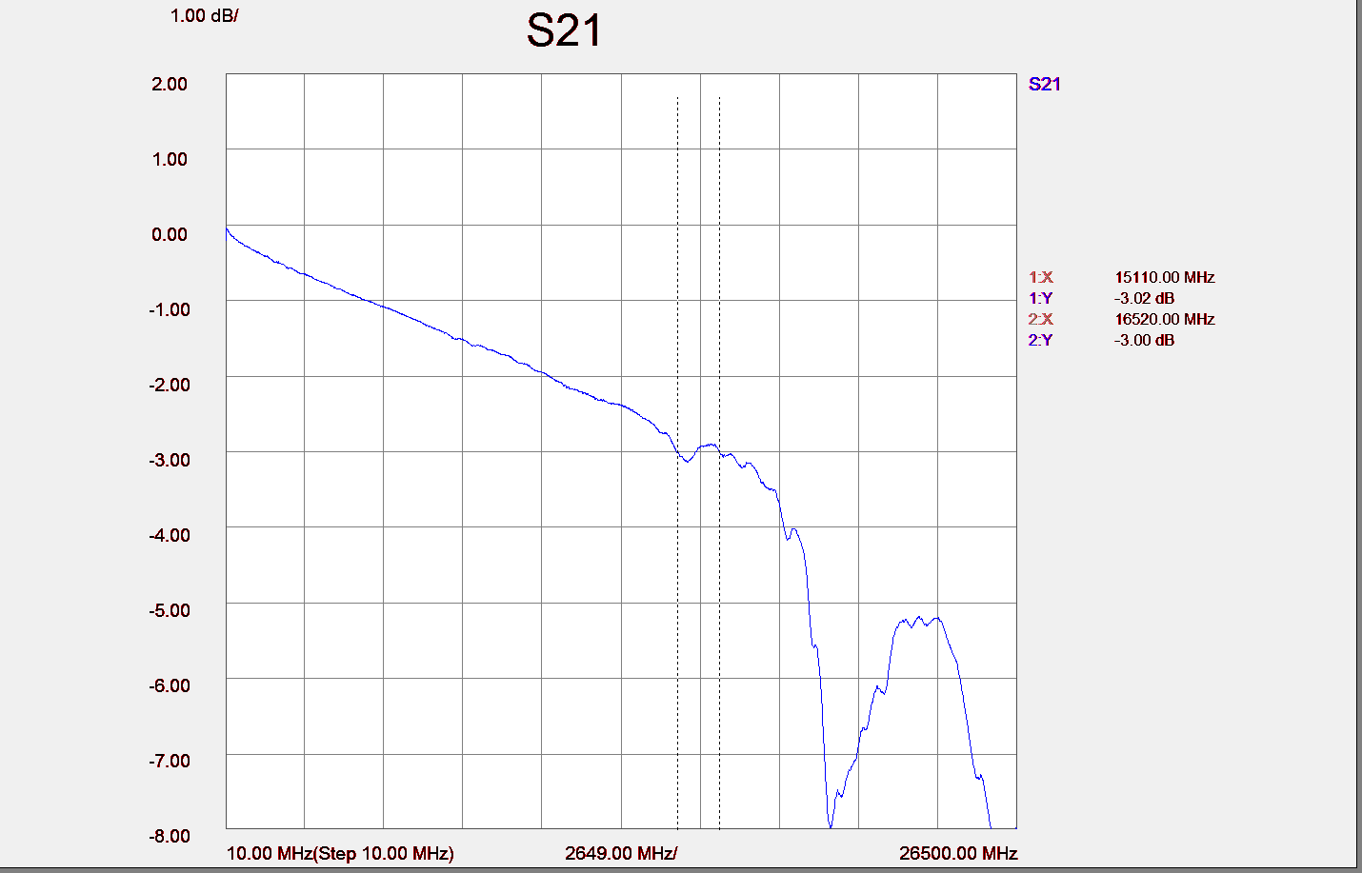
Figure 6. Typical 2X-THRU insertion loss

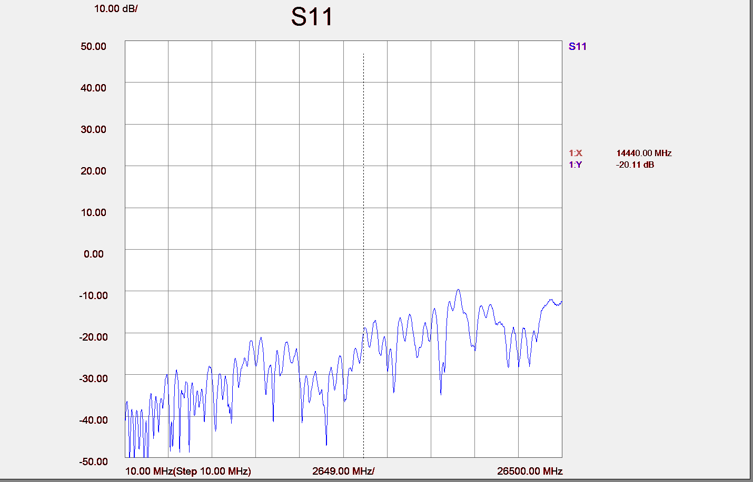
Figure 7. Typical 2X-THRU return loss
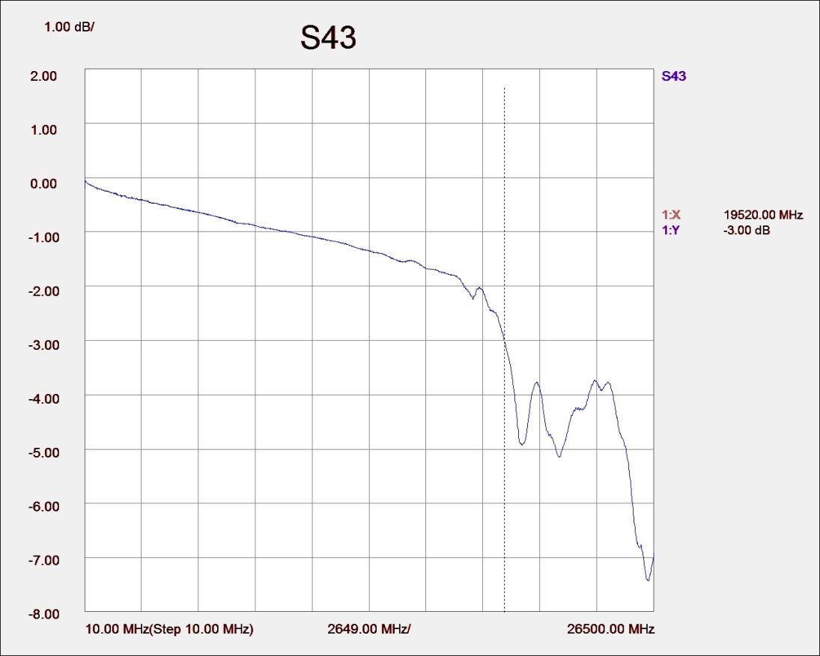
Figure 8. Typical 1X-THRU insertion loss

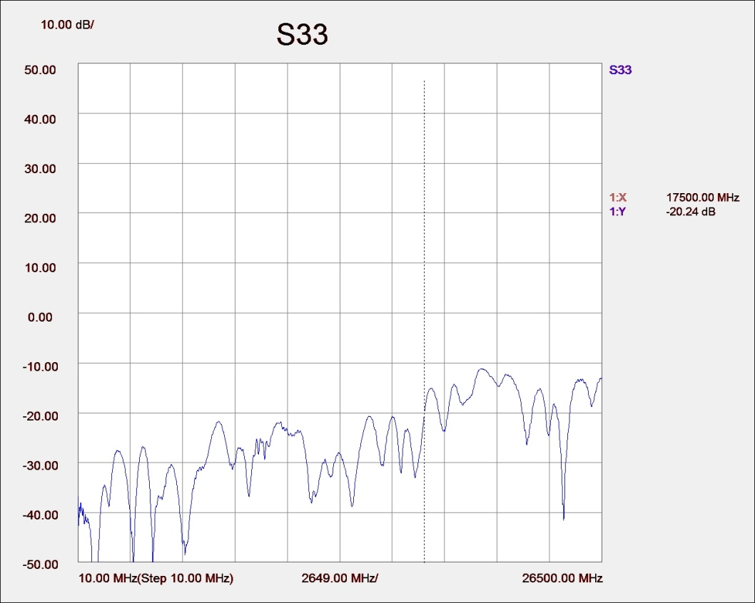
Figure 9. Typical 1X-THRU return loss
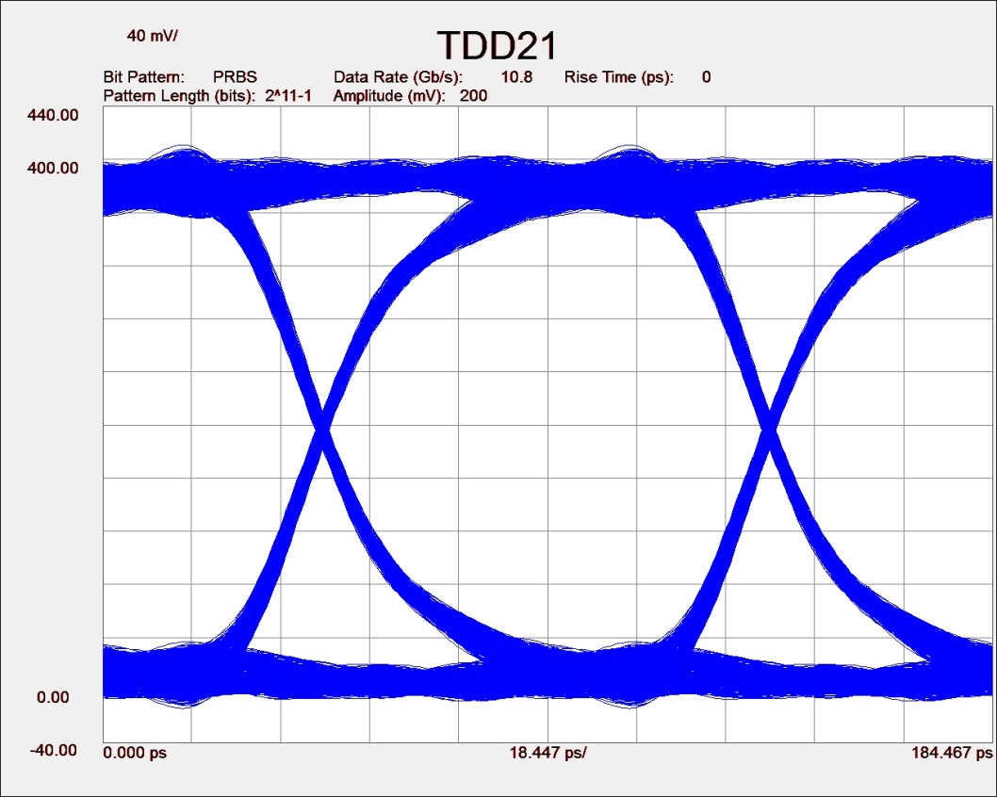

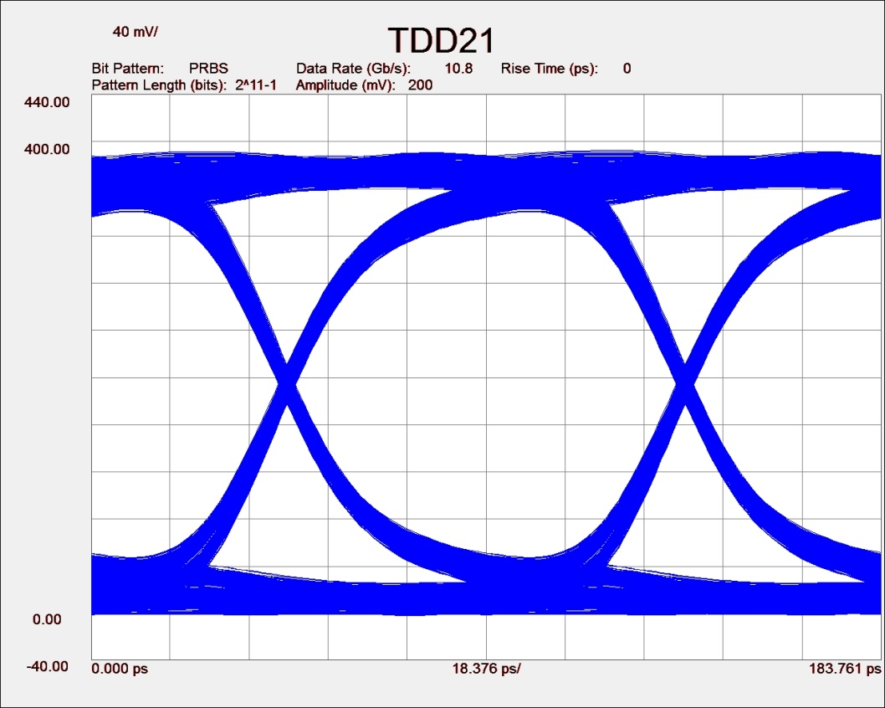
Figure 10. Typical mated pair 10.8 Gb/s eye diagram, with calibration (top) and without calibration (bottom)

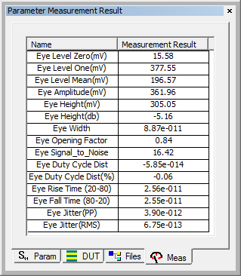

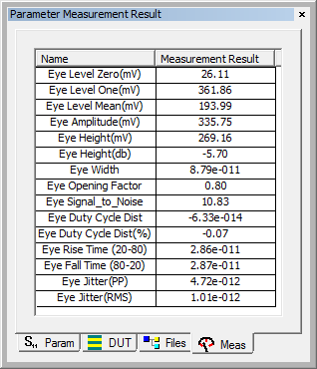
Figure 11. Typical mated pair 10.8 Gb/s eye data, with calibration (top) and without calibration (bottom)

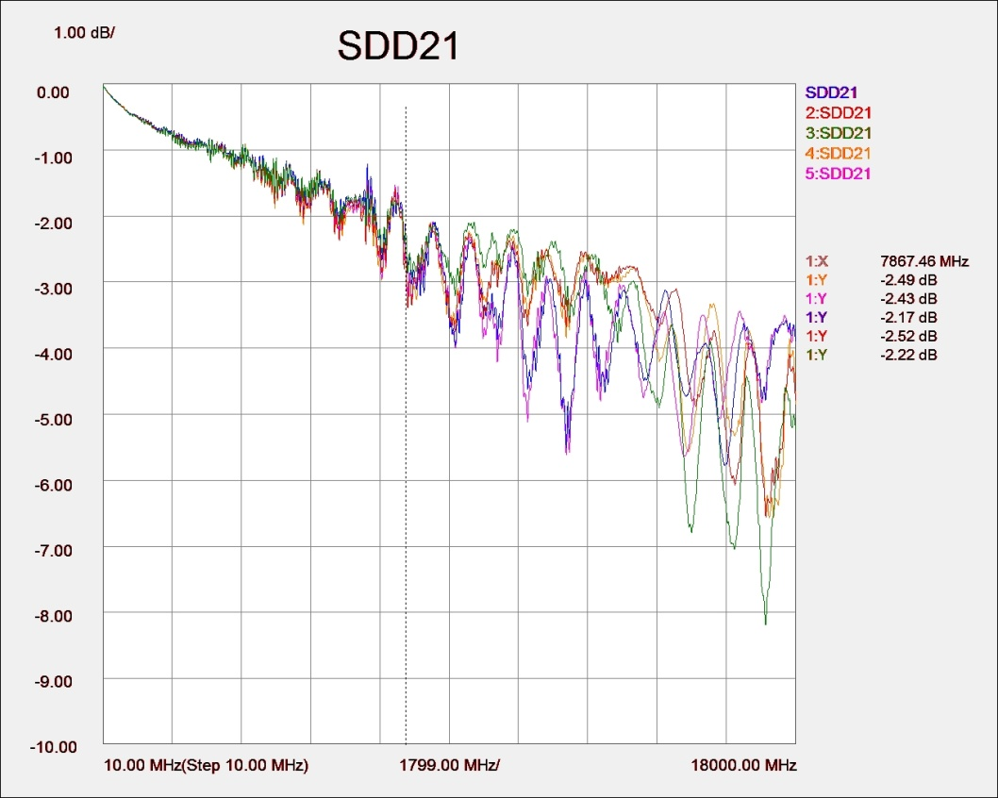

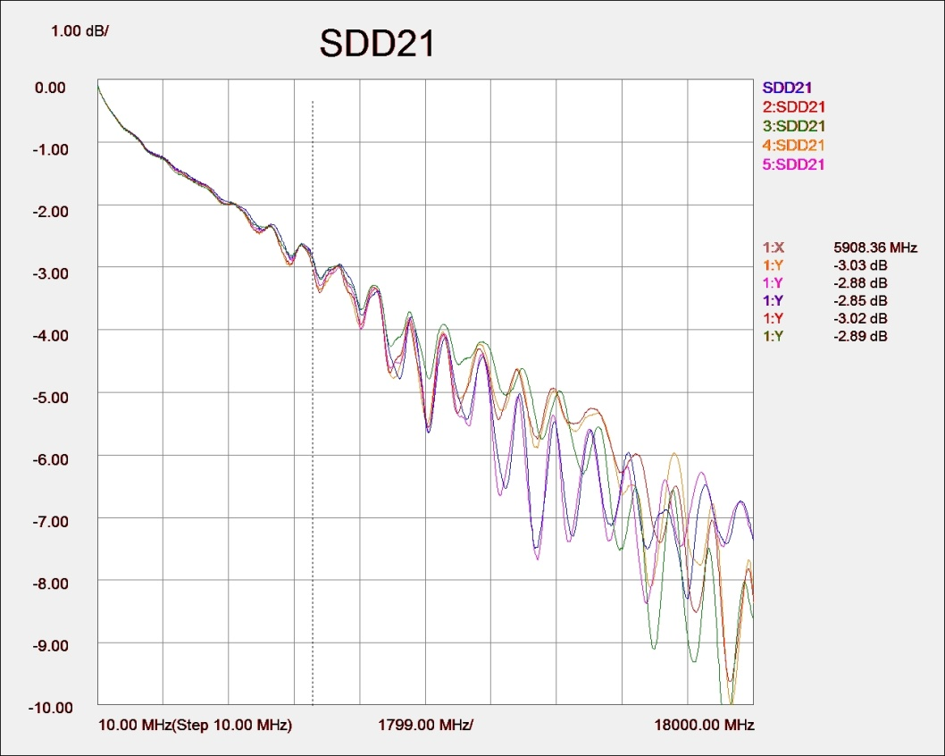
Figure 12. Typical mated pair balanced insertion loss

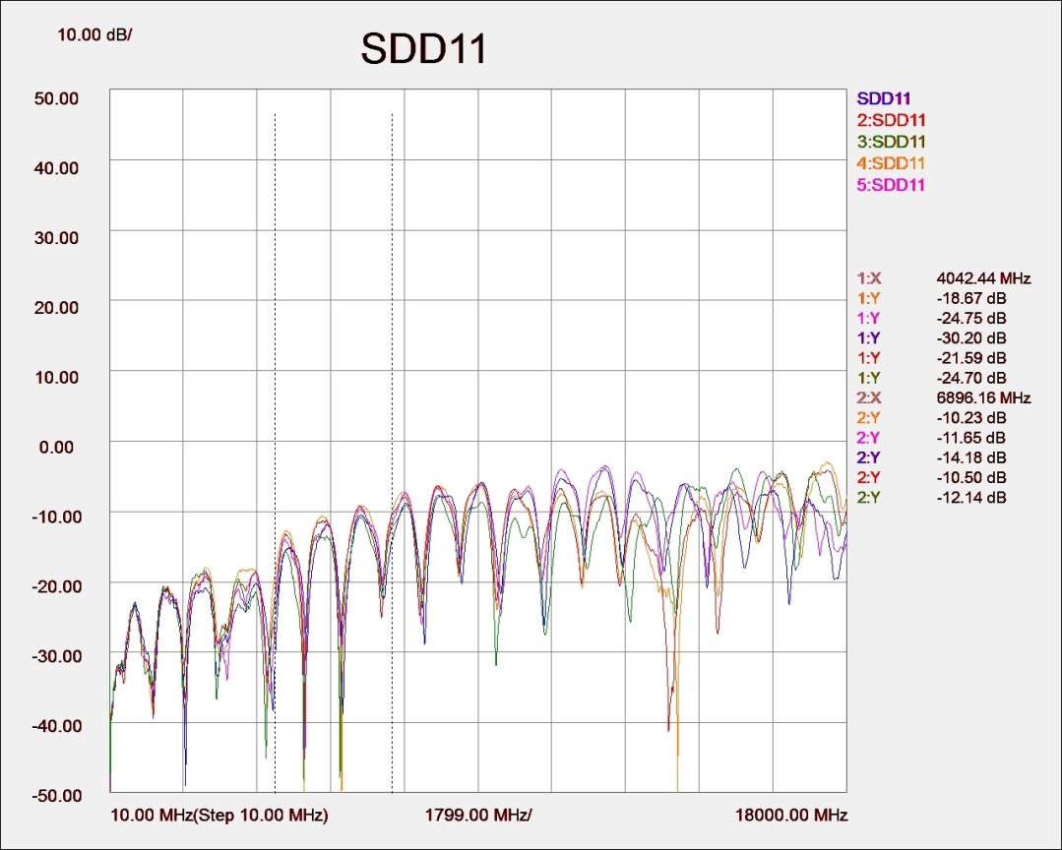

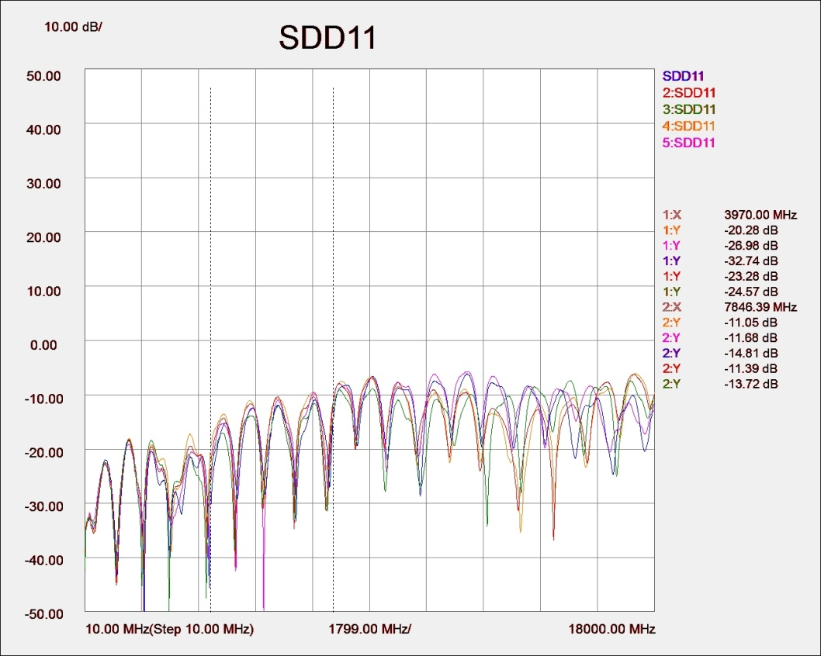
Figure 13. Typical mated pair balanced return loss, with calibration (top) and without calibration (bottom)

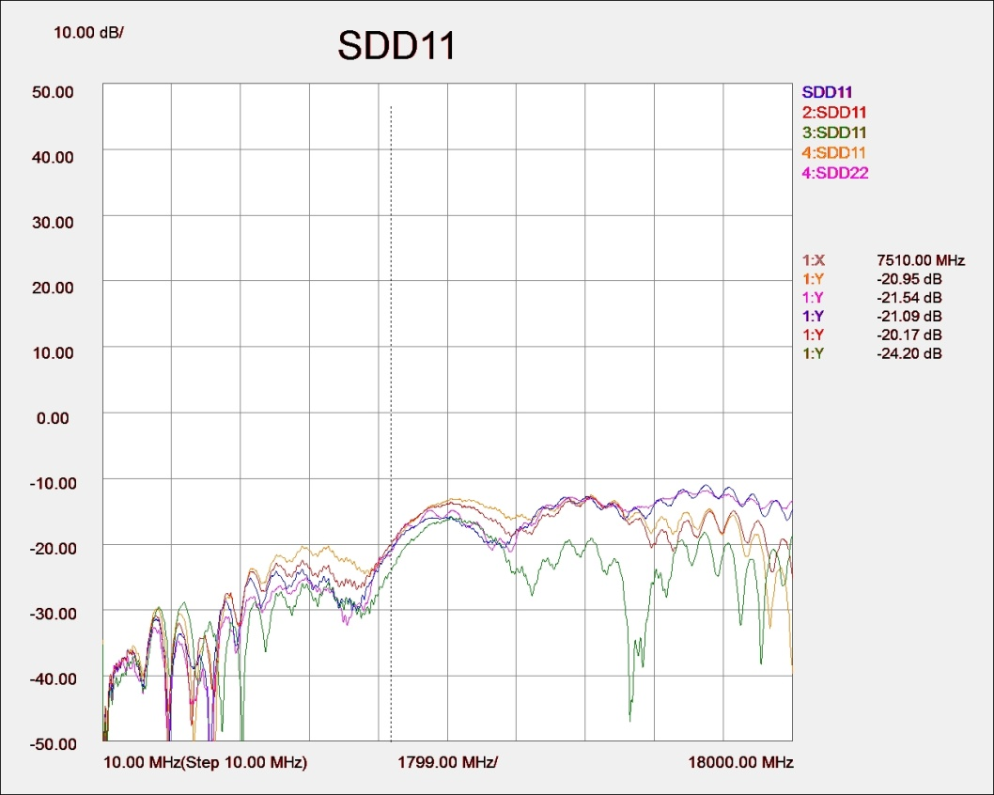
Figure 14. Typical balanced return loss, without connector, all lanes terminated at both ends

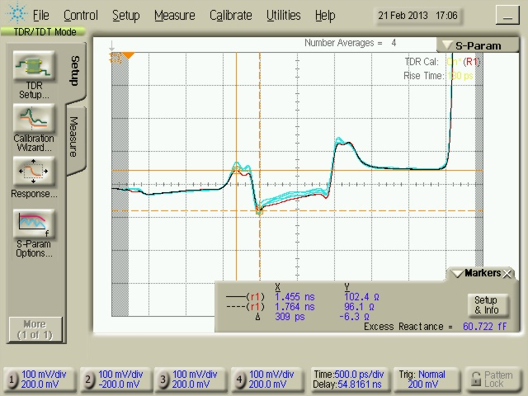
Figure 15. Typical differential TDR of TPA-R connected to Micro-Coax Display Patch cable at 130 ps Rise Time. TDR of TPA-R through 4 inch cable, then through a second TPA-R.

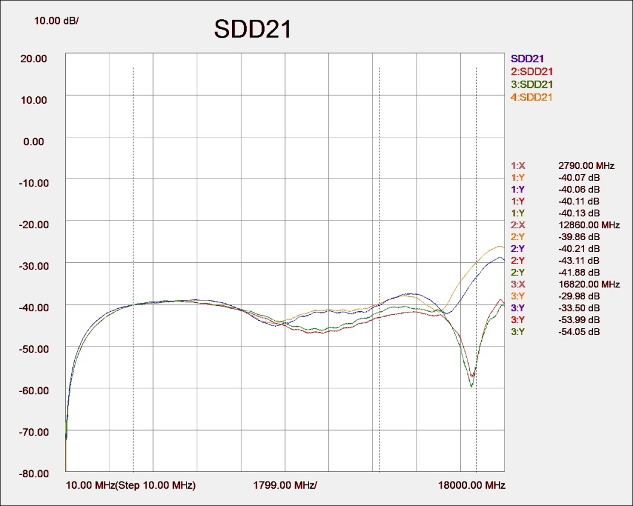

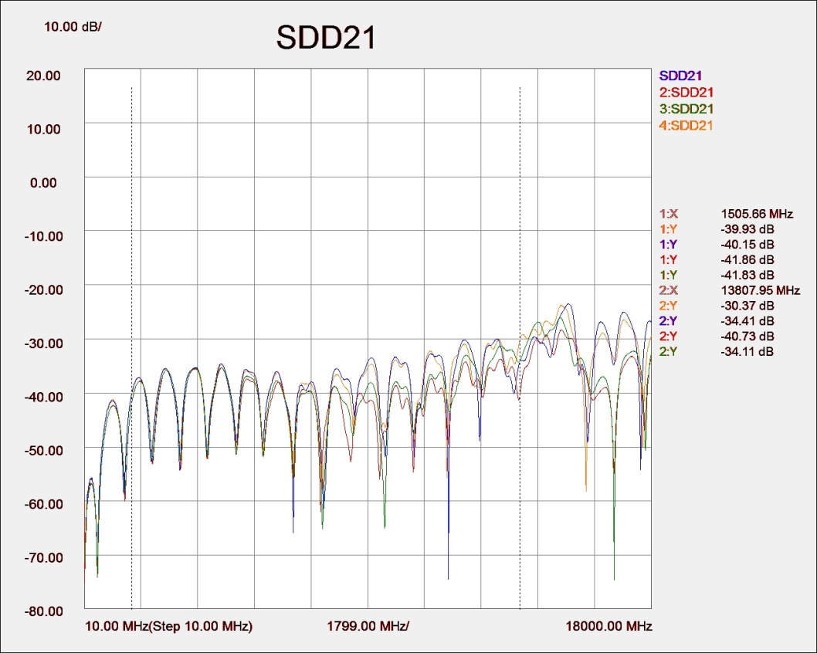
Figure 16. Typical Differential NEXT, without connector (top) and with mated connectors (bottom), all lanes terminated at both ends

Compliance with Environmental Legislation
Wilder Technologies, LLC, is dedicated to complying with the requirements of all applicable environmental legislation and regulations, including appropriate recycling and/or disposal of our products.


WEEE Compliance Statement
The European Union adopted Directive 2002/96/EC on Waste Electrical and Electronic Equipment (WEEE), with requirements that went into effect August 13, 2005. WEEE is intended to reduce the disposal of waste from electrical and electronic equipment by establishing guidelines for prevention, reuse, recycling and recovery.
Wilder Technologies has practices and processes in place to conform to the requirements in this important Directive.
In support of our environmental goals, effective January 1st, 2009 Wilder Technologies, LLC has partnered with EG Metals Inc. – Metal and Electronics Recycling of Hillsboro, Oregon, www.egmetalrecycling.com, to recycle our obsolete and electronic waste in accordance with the European Union Directive 2002/96/EC on waste electrical and electronic equipment ("WEEE Directive").
As a service to our customers, Wilder Technologies is also available for managing the proper recycling and/or disposal of all Wilder Technologies products that have reached the end of their useful life. For further information and return instructions, contact support@wilder-tech.com.





Compliance To RoHS 2 Substance Restrictions
Wilder Technologies, LLC certifies that the parts described in this document are compliant to the substance restrictions of Directive 2011/65/EU and Amendment Directive (EU) 2015/863 of the European Parliament, and of the Council of 8 June, 2011 and 31 March, 2015 on the restriction of the use of certain hazardous substances in electrical and electronic equipment (RoHS 2 Directive), prohibiting the use in homogeneous materials in excess of the listed maximum concentration value, except in cases where use is allowed by applicable exemptions listed in Annex III and Annex IV of the Directive.
Compliance with RoHS 2 has been verified through internal controls at design and production sites, including establishment of processes for specifying and controlling materials and segregation of non-compliant parts, receipt of supplier declarations of compliance and/or analytical test.

Glossary of Terms

Terminology | Definition
Aggressor | A signal imposed on a system (i.e., cable assembly) to measure response on other signal carriers.
AUX Channel | A half-duplex, bi-directional channel within the DisplayPort interface; short for “Auxiliary Channel”. Consists of one differential pair transporting self-clocked data. The DisplayPort AUX Channel supports a bandwidth of 1Mbps. The DisplayPort Source is the master that initiates an AUX Channel transaction. The DisplayPort Sink is the slave (also referred to as AUX Channel Replier) that replies to the AUX Channel transaction initiated by the Requester.
DisplayPort Receiver | Circuitry that receives the incoming DisplayPort Main Link data. Also contains the transceiver circuit for AUX Channel. Located in Sink Device and in the upstream port of any Intermediate Device.
DisplayPort Transmitter | Circuitry that transmits the DisplayPort Main Link data. Also contains the transceiver circuit for AUX CH. Located in Source Device and in the downstream port of Intermediate Device.
EDP-TPA | Embedded DisplayPort Test Point Access. A specialized assembly that interfaces to an Embedded DisplayPort connector and enables access of signals for measurement or stimulation.
EMI | Electro-Magnetic Interference
HPD | Hot Plug Detect
Informative | The designation of a test that is not required for compliance but is considered important from a characterization standpoint. It is provided for informational purposes only.
Main Link | Unidirectional channel for isochronous stream transport from Embedded DisplayPort Source to Embedded DisplayPort Sink. Consists of 1 or 2 lanes, or differential pairs. Supports 2 bit rates: 2.7Gb/s per lane (referred to as “High Bit Rate”) and 1.62Gb/s per lane (referred to as “Reduced Bit Rate”).
NEXT | Near-end Crosstalk
Normative | The designation of a test that is required for compliance.
Sink Device | Contains one sink function and at least one rendering function, and is a Leaf Device in a DisplayPort tree topology. A device that receives A/V stream sinks for video display and/or sound reproduction.
Source Device | A device that contains an A/V stream source and originates an isochronous A/V stream.
Victim | A signal carrier on a system that has a response imposed on it by other signals in the system.

Index

1X-THRU, 16
2X-THRU, 15
Cable Bend Limits, 7
Cable Losses, 16
Cable Tension (Pull Forces), 7
Cable Twisting (Torque), 7
Calibration, 14
Calibration Through De-Embedding, 17
Care and Handling, 7
Cleaning, 9
Compliance
RoHS, 34
WEEE, 34
Connections
EDP-TPA to DUT, 7
SMA, 8
Crosstalk Errors, 15, 17
De-emphasis, 16
Directivity Errors, 15, 17
DisplayPort CTS PHY 1.2, 11
Drift Errors, 15, 17
DUT, 15, 17
EDP-TPA Cable Pinout, 18
Electrical Specifications, 23
Electrostatic Discharge Information (ESD), 10
Embedded DisplayPort TPA and Micro-Coax Cable as a Sink, 11
Embedded DisplayPort TPA and Micro-Coax Cable as a Source, 12
Embedded DisplayPort TPAs as a Source and Sink, 13
Environmental Changes, 15, 17
Errors
Crosstalk, 15, 17
Directivity, 15, 17
Drift, 15, 17
Load Impedance Mismatching, 15, 17
Random, 15, 17
Receiver Reflection-tracking in Test Equipment, 15, 17
Receiver Transmission in Test Equipment, 15, 17
Source Impedance Mismatching, 15, 17
ESD Protection, 10
Figures
As-Tested Configuration, 24
Cable Connectors, 18
Calibration Module, 14
The eDP DisplayPort Test Adapter (Receptacle with Patch Cable), 5
The eDP DisplayPort Test Adapter (Receptacle), 4
Flip-Lock Feature, 7
Glossary, 35
Group Delay, 16
Handling and Storage, 9
Load Impedance Mismatching Errors, 15, 17
Low-Speed Connector, 5
Low-Speed Connector Part Numbers, 5
Low-Speed Connectors, 3, 18
Making Connections, 9
Mechanical and Environmental Specifications, 18
Molex Part Numbers, 5
Pin-1 Physical Location, 4, 5, 18, 22
Plug Connectors, 22
Pre-emphasis, 16
Product Inspection, 6
Product Return, 6
Pull Force, 8
Random Errors, 15, 17
Receiver Reflection-tracking in Test Equip. Errors, 15
Receiver Reflection-Tracking in Test Equip. Errors, 17
Receiver Transmission in Test Equip. Errors, 15
Receiver Transmission in Test Equipment Errors, 17
Receptacle Connectors, 22
RoHS, 34
Secure Storage, 6
SMA Cables, 18
SOLT, 15
Source Impedance Mismatching Errors, 15, 17
Support, 17, 34
Supporting Instrument Cables or Accessories, 8
Swing-Latch, 7
Tables
EDP Receptacle Pin Assignments, 21
EDP-TPA 20-Position Cable Connector, 20
EDP-TPA 6-Position Cable Connector, 19
Electrical Specifications, 23
General Specifications, 18
SMA Cable Connectors (High-Speed), 19
Test Instrument Noise, 15, 17
Test Repeatability Problems, 15, 17
User Model Examples, 11, 12, 13
VESA DisplayPort™ PHY Compliance Test Spec., 3
Visual Inspection, 9
Web Sites
support@wilder-tech.com, 34
www.egmetalrecycling.com, 34
WEEE, 34

Visit our website at www.wilder-tech.com

Wilder Technologies, LLC
11201 NE 9th St.
Vancouver WA, 98684
Phone: 360-859-3041
Fax: 360-859-3105
www.wilder-tech.com

©2024 Wilder Technologies, LLC
Document No. 910-0029-000 Rev. D
Created: 2/11/2013 Revised: 2/29/2024

